Human African Trypanosomiasis gambiense in the Democratic Republic of Congo
Creating a framework for Post-Elimination Surveillance

- General Introduction / Setting the scene

  - Human African Trypanosomiasis

  - Introduction
  - Two forms
  - Clinical picture
  - Historical perspective
  - Epidemiology
  - DRC
  - Surveillance: AS vs PS

  - A Disease Approaching Elimination + Significance

  - WHO 2030 elimination goals and progress (as public health problem and elimination of transmission)
  - What is necessary? (elimination strategy according to WHO)
  - Current achievements in different foci is elimination achievable?

  - Key Challenges / Problem statement

  - Limitations of the current surveillance system
  - We do not know if elimination is feasible
  - Reduced funding and AS expensive
  - Primary health care system in bad state integration of passive screening difficult
  - Sustainibility

  - Aim and Research questions: The Post-Elimination Challenge

  - Analyze historic data to estimate if elimination is achievable? Going from current knowledge to advanced analysis of 25 years of data.
  - What is the current state of the surveillance system? We aim to assess Quality of AS activities? alternatives (PS article)
  - Quality of current system (screening performance and detection coverage)
  - AS to VS based on epi thresholds?
  - How should surveillance systems transition from elimination to post-elimination phases?
  - If we imagine passive screening in primary health care and active screening to verify elimination, what should be the sampling strategy?

1.5 Outline and key messages of the thesis

Elimination is achievable (Article 1) BUT the current surveillance system has its limitations.

In particular, we were able to analyze the performance of the mobile teams in active screening in regard to the execution of the screening test (Article 2). We demonstrated that the result of the screening tests that are used in the DRC are for 28% dependent on by which team the test was executed. We also evaluated (Article 3) the HAT surveillance system for one its key criteria, which hadn’t been evaluated before, the detection coverage. While most of the area at risk and the cases seem to be covered there are still gaps.

We aimed to develop alternatives which can serve as building blocks for the post-elimination system, which respond to the previous challenges. We developed a new kind of passive surveillance system, based on a simplified diagnostic algorithm (Article 4) which addresses the hurdles that were previously encountered by other attempts to integrative passive surveillance. For the passive case detection system to be as efficient as possible, and provide an alternative for a large part of active surveillance (which will never completely disappear), we developed a methodology to target health facilities for integration (Article 5?).

Finally, we calculated through mathematical modelling the sampling interval based both for villages which are located within the detection area of passive screening and of those outside of those boundaries, which will be the basis for a possible post-elimination surveillance system (Article 6).
Within a post-elimination surveillance context for HAT in the DRC, where the new passive case detection is introduced in all the endemic provinces we estimate that the latter will cover ### % of the area at risk (low or high), ### % of the villages at that were at some point at low risk and ### % of the villages that were at some point at high risk. Furthermore, active surveillance will need to be done every ### years for villages at low risk and every ### years for villages at high risk.

- Methodology

  - Analysis of historic routine data

  - More in depth analysis of data provided by TRYPELIM which is more detailed

  - Projection and modelling based on historic + Trypelim data, according to risk estimations

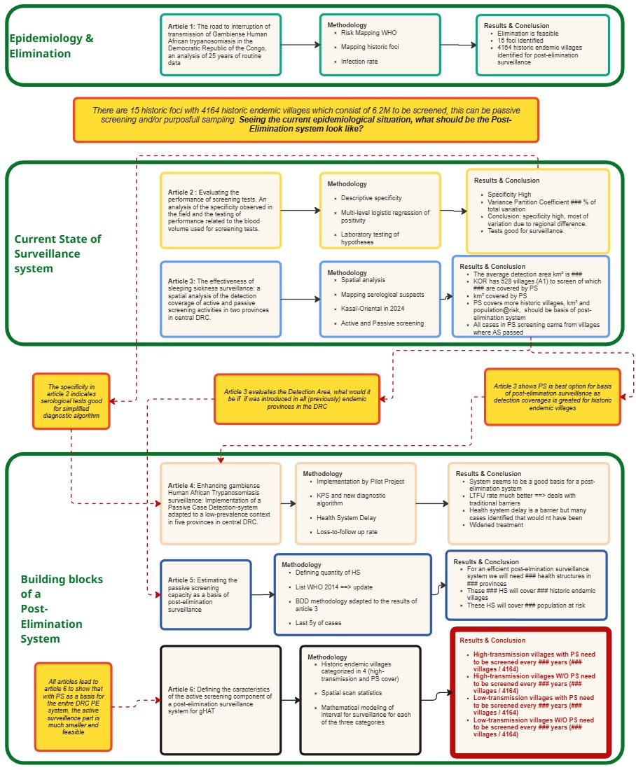

- Results

  - Chapter 3: Findings for improving our current state of knowledge

Article 1: Over the past centuries gHAT is known for its tendency of resurgence. It is therefore crucial to outline not only areas of persistent transmission but also areas at risk of resurgence, called HAT-foci. The former to reach elimination, the latter to target for post-elimination surveillance. We applied a methodology developed by WHO to outline areas at risk for the period 2000-2024. The areas at risk have contracted dramatically, with a 67% reduction in low-risk areas (incidence ≥1 per 100,000) and a 97% reduction in moderate-to-high-risk areas (incidence ≥1 per 10,000). Over the years we identified 15 distinct HAT foci, with three accounting for over 80% of cases. Currently the epidemic is concentrated in a few foci. Sustained interventions and robust post-elimination surveillance remain imperative, but combined with acoziborole—a new single-dose oral drug for presumptive treatment of serological suspects—interruption of transmission appears an achievable goal.

  - Chapter 4: Findings for analyzing the state of the current surveillance system in the DRC

Article 2: Quality variation in active surveillance operations which have a big impact as the surveillance system is build for an endemic disease but less performant for a disease with reducing prevalence. This raises questions about long-term sustainability of active surveillance. Low prevalence amplifies impact of test performance issues

Article 3: Detection coverage has previously been described as a key determinant to measure the impact of gHAT control programs. Mathematical modelling (Chechhi) has shown that passive screening has the potential to identify a lot of cases, but that it is heavily dependent on the coverage of its activities. Active screening activities have not been described yet in relation to their potential coverage. At the same time, this indicator will gain more importance as we are on the road to Elimination of Transmission by 2030 (WHO) and as we get closer to a screen-and-treat strategy (STROgHAT). It will also be a crucial component for post-elimination strategies.
As efforts intensify to eliminate gHAT in the Democratic Republic of the Congo, it is crucial to understand how well active and passive screening strategies are aligned and how effectively they complement each other. Key questions arise: Are cases detected through passive screening originating from villages also visited by active screening teams? Does passive screening sufficiently cover “historic” villages—those with reported cases in the previous ten years (lists 1 and 2)? What geographic areas are effectively covered by each health facility conducting passive screening? And among cases found through passive screening, had they previously been tested during active screening, and what were their results?
Besides the mapping of case that are within the detection areas of active and passive screening we also concluded that, for all the health structures that were evaluated, that people were able to access these structures if they lived in a ### vicinity.
We found that the average detection area for passive screening facilities, in urban areas, was a circle with a ### radius. When looking at the Kasaï-Oriental context we can see that ### of the population fell inside the detection area of the passive screening facilities. ### Cases came from a village within this detection area. From the #### villages that need to be surveilled for post-elimination surveillance, within the KOR area/focus, #### fall withing the passive detection area.

  - Chapter 5: Findings for the development of the building blocks of a post-elimination surveillance system

Article 4: The objective of the project described in this paper was to evaluate the development and assess the feasibility to implement a passive case detection system which would address most of the beforementioned constraints, which are inherent to the DRC. Firstly, the project aimed to define a novel set-up for the integration of passive screening activities in the standard health care system in DRC, by simplifying the diagnostic algorithm at field level, and a rational use of resources. This way the system would be less reliant on specialized skills and more adapted to the local context and its resource constraints. Secondly, the project aimed to address the challenge of loss to follow-up by combining a new blood sampling kit (BSK) with a new digital platform, which means that the sero-suspect does not have to travel to get a confirmation. Thirdly, a strategy was developed to select health facilities for passive case detection, which allowed the system to be extended and customized to the local context, while not using too many resources.

Article 5: We applied the same methodology as was used for the selection of health structures in Bandundu Sud. Strategy for targeting health structures for passive screening based on two methodologies: satscan and risk mapping. Based on the WHO list from 2014 to have an update about their functionality, how much investment. How many need to be changed to the new strategy. The end result would be a list of health structures that would be the basis for a post-elimination surveillance system and seeing the detection coverage that has been calculated in the Article 3, these would cover a ### amount of to-be-surveilled-villages that are covered by this passive case detection system.

Article 6: in a Passive-dominant surveillance system, the part that active surveillance would play would be much reduced. Through mathematical modelling we were able to estimate the time intervals for villages that were once at low or at once high risk (or within detection area for passive screening). For a province that has reached elimination, an interval of ### years would suffice to check for resurgence of the disease if ### (epi conditions), otherwise ###.
We might go for three categories of villages:
- Villages covered by passive screening
- Non high-transmission villages not covered by passive (outside of satscan/historic transmission circles)
- High-transmission villages not covered by passive screening (inside satscan circles) which would indicate there is a heightened risk of undetected transmission.

- Discussion

Interpretation of findings:

The Surveillance Strategy Dilemma
  - Both active and passive surveillance have roles
  - But which is more appropriate as elimination approaches?
  - Active: intensive but quality-variable and costly
  - Passive: sustainable but dependent on health systems
  - We showed a lightweight approach to passive case detection which can be the cornerstone for post-elimination surveillance

Limitations: Sustainability of post-elimination system
  - Primes
  - Donor fatigue
  - Cost per case
  - Knowledge challenge addressed
  - Multi-NTD might offer some solutions

Implications:
  - Longest longitudinal HAT surveillance analysis
  - Implementation of passive case detection system that addresses certain hurdles for the first time.
  - Sampling + interval of survey food for further discussion.
  - For policy:
    - Quality improvement for active screening
    - Suggestion for trial in province where elimination has been reached

- Conclusion

We show elimination is possible, now we need to find a way once we reach it how we keep it from resurgence
  - Screen-and-treat looks promising to reduce reservoir
  - Many diseases targeted for elimination, hope that reflection about post-elimination surveillance system feeds discussions for others

At this point in time we are not able to define the final framework for post-elimination surveillance as there are still multiple questions. We await the results of the screen-and-treat research as this will probably become the modality for all the active screenings that will be done. Funding will also define what the final operational modality will look like. What is the capacity that will be available in the future. These answers will determine what the sampling strategy will look like.

